OudhTrade
Backend Technical Design
Module 1 — Platform Foundation · M01-3
Document details
Company | MRIDA INFRA AND PLANTATIONS LLP
Product | OudhTrade — oudhtrade.com
Document | M01-3 Backend Technical Design
Module | M01 Platform Foundation (release R1)
Readers | Backend developers, DevOps, tech lead
Related documents | PRD (PRD-FND, PRD-CMP) · HLD · other M01 documents
Owner | Tech lead
Decision owner | T. Satish Reddy, CEO & Founder
Status | Draft for review — 24 September 2026
Classification | Confidential — for partners and the OudhTrade team

Contents
1. Overview 2
2. File & Media Pipeline 4
2.1 File states 6
3. Internal Interfaces 7
4. Public API Endpoints (v1) 8
4.1 API rules for all modules 10
4.2 Settings API 11
4.3 Error codes 13
5. Events and Jobs 14
5.1 Events Module 1 reacts to 15
6. Audit Log Design 15
7. Units, Locale and URL Details 16
8. Configuration, Security and Performance 17
9. Environments and Pipeline 18
9.1 Backups, standby and disaster recovery 18
10. Rate Limits 19
11. Edge Security Design 20
12. Country & Currency Design 20
13. Threat Model (STRIDE) 21
14. AI Gateway Design 21

1. Overview
Module 1 is a set of shared services inside the Core API and the workers (HLD Section 4). Other modules call them through small internal interfaces; they never access the 37 Module 1 tables directly (M01-5). The backend language and framework follow the team’s approved technology proposal (HLD 13.2).
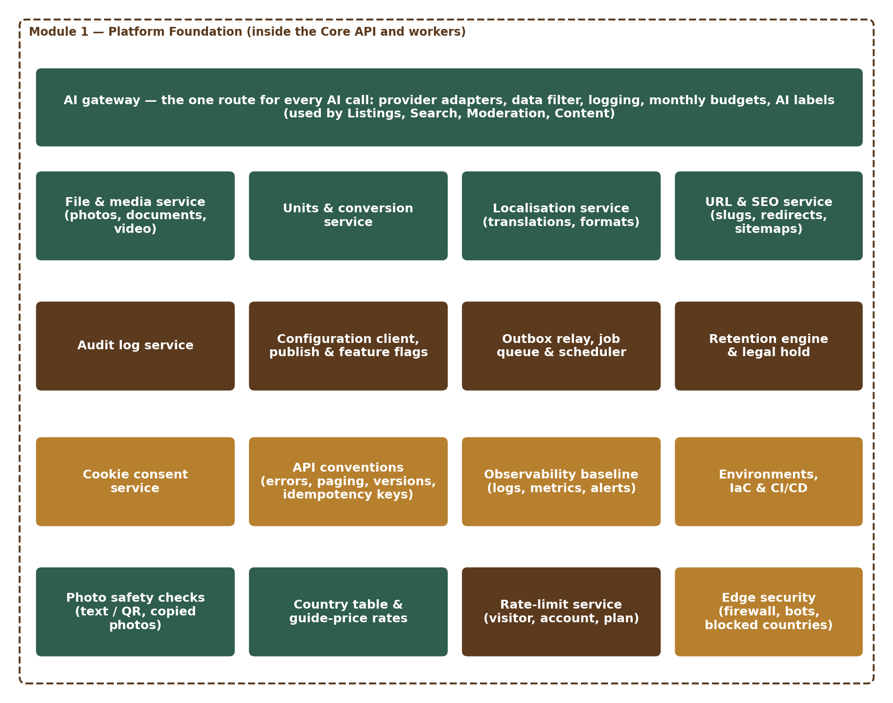
Figure 1 — Module 1 services
Service | Responsibility | Runs in
FileService | Upload slots (pre-signed POST with size limit), quarantine, scan, variants, signed links, attach / detach, moderation decisions, cleanup | API + worker
MediaService | Photo conversion (HEIC→JPG, WEBP) and document conversion (HEIC / HEIF / WEBP → JPG for reviewers) with decode limits, resize, location-data removal, face blur (blurred public copy), watermark; video checks, 720p conversion and compression, cover image | Worker
ImageSafety | Text and QR-code detection in photos and video covers; photo fingerprints and copy matching; block list | Worker
UnitService | Unit list, conversions, state area factors, price-per-standard-unit | API (cached)
LocaleService | Translations, number / date / currency formatting, phone and address formats, trade-term word list, IST business-hour calculator with holiday calendar | API + web
CountryService | Country table, states / regions, country status and feature rules, daily exchange rates, guide price | API (cached) + worker
RateLimiter | Shared limits per visitor, account, plan and action group; rate-limit headers; blocks and security events | API (Redis)
UrlService | The one store of page addresses (url_slugs): store web address made from the business name (transliteration or suggestions for other scripts), reserved-name checks, redirects (including after profile.renamed), sitemaps, indexing rules | API + worker
AuditService | Write, hash-chain sealing and daily check, search (role-scoped), safe export, nightly archive | API + worker
ConfigClient & ConfigService | ConfigClient: read versioned configuration and feature switches with cache and defaults. ConfigService: drafts, preview impact, send for approval, approve / reject, publish (now or scheduled), cancel, roll back, emergency switch-off, version history, export / import (Section 4.2; called by the settings screens and the Configuration Console, M16) | All · API
EventBus (outbox) | Write events in transaction, relay, handler registry, idempotency | API + worker
JobRunner & Scheduler | Database-backed jobs, retries, dead-letter list and staff re-run, timed tasks | Worker
RetentionEngine | Retention policies, daily job, anonymisation, legal holds | Worker
ConsentService | Cookie consent records, account-level choice, cookie-free KPI counters | API
AIGateway | The one route for every AI call: provider adapters, data filter, logging, budgets, output labels (Section 14) | API + worker
Platform middleware | Request ID, error format, idempotency keys, rate-limit check and headers, security headers, pagination, version routing and deprecation headers | API
Edge (infrastructure) | CDN, web application firewall, bot control, geo-blocking of blocked countries, denial-of-service protection | AWS edge

2. File & Media Pipeline
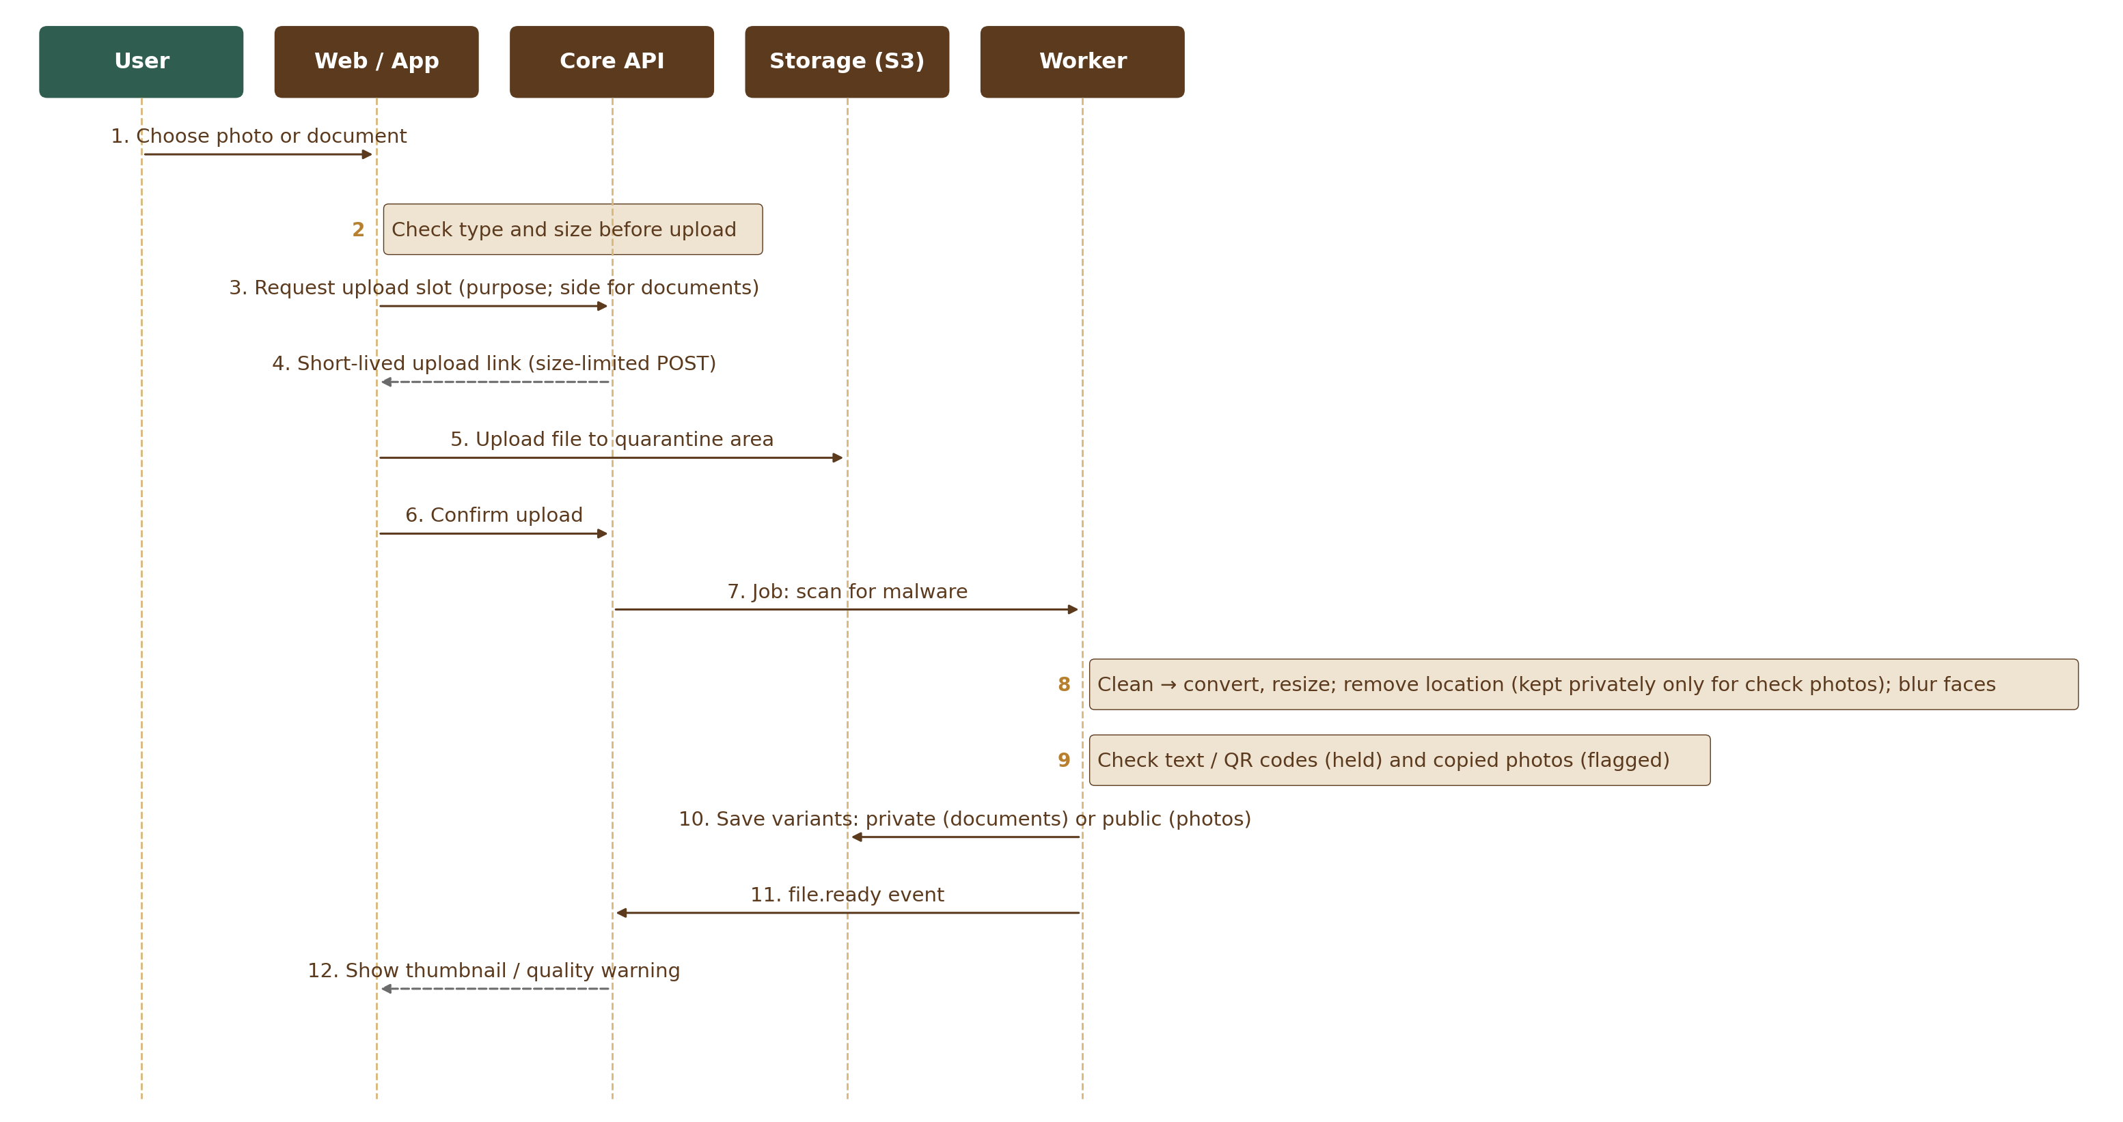
Figure 2 — Photo and document upload sequence
- Direct-to-storage upload (SEC-011): the API issues a short-lived pre-signed S3 POST for one object key in the quarantine prefix (`quarantine/{fileId}`). The POST policy carries a `content-length-range` condition set from the purpose’s size limit (listing photo 15 MB, document 10 MB, video 100 MB, business location video 45 MB — all settings, M01-2 Section 18) and the expected content type, so storage itself refuses a larger file. The file never passes through the API server. Video uses multipart upload with resume; the declared size is checked before part links are issued and the real size again at the confirm step.
- Unconfirmed uploads: an S3 lifecycle rule on the quarantine prefix deletes objects 24 hours after upload; the hourly `uploads.cleanup` job marks slots that were never confirmed as `expired`.
- Confirm step: client calls `POST /v1/files/{id}/complete`; API checks size and type (magic bytes, not only extension) and enqueues `file.scan`.
- Scan: ClamAV worker scans the object; clean → `file.process`; infected → object deleted, file marked `rejected_infected`, audit record written.
- Decode limits (against decompression bombs): the worker reads the image header first and refuses images above 40 megapixels or 12,000 px on a side (starting values, configurable) before decoding; decoding runs in a separate process with a memory cap (1 GB) and a time-out (HEIC 15 s, other formats 10 s; starting values, tuned in load tests). A refused image is marked `failed` with reason `image_too_large` and the seller sees “This photo is too large to process”.
- Photo processing: decode (incl. HEIC); location data (GPS) is kept in the private original only for the purposes farm_visit_photo, verification_doc / verification_photo, location_photo and origin_doc / origin_photo (FIL-022) and is stripped at upload from the original too for every other purpose; all other EXIF data is removed; location is stripped from all variants; auto-orient, create variants (thumb 320, medium 800, large 1600; WEBP + JPG), optional watermark on public variants, quality score (size + blur).
- Face blur (FIL-028): for farm_visit_photo and location_photo (and any purpose a module adds), a face detector runs on the processed image; MediaService makes the variant `blurred` with every face blurred and builds all public sizes from it (M01-5 Section 2.2). Staff add or fix blur boxes on the M03 farm-visit review screen (M03-AD-03); the M03 endpoint calls `FileService.applyBlurBoxes`, the blurred copy is made again, and approval follows. If face detection fails, no public variant is made and the photo stays private until a person checks it.
- Photo safety: text detection (OCR) and QR-code reading on the medium variant and on video cover images; patterns for phone numbers (all countries), email, UPI ID and web addresses; a hit sets status `held` and emits `file.held` (reason: contact details or QR code) for Module 12. A perceptual fingerprint (64-bit pHash) is stored per photo with four 16-bit bands for fast search (M01-5 Section 2.1); a match within a configurable distance (3 bits to start, tuned on real photos before R1; some heavily edited copies may be missed) against another seller’s photo sets `duplicate_suspected` on the file — its status stays `ready` or `attached` and the photo stays visible — and emits `file.held` with reason `duplicate_suspected` so Module 12 reviews both listings in its copied-photo queue; block-list matches are rejected. Tool choice (self-hosted OCR / QR libraries or a managed service in Mumbai) is part of the team proposal.
- Moderation decisions: Module 12 never calls FileService directly. Its decision arrives as the event `moderation.file_decided`: approve → `ready` (video live); reject → `rejected` with reason; copied, stock or banned photos are also added to `image_blocklist`.
- Documents: accepted as PDF, JPG, PNG, HEIC / HEIF or WEBP (FIL-008). After the scan, HEIC / HEIF and WEBP documents are converted to JPG (same decode limits as photos) so reviewers can open them in the viewer; the original is kept privately. Stored in a private bucket. `GET /v1/files/{id}/link` returns a signed URL valid 5 minutes (configurable) to the file’s owner only; staff never get a signed link — they see documents in the watermarked viewer of Module 3, which streams the file through `FileService.streamForViewer` (M03 permissions, audited). Each call is audited.
- Video processing: probe duration and codec; reject a listing video > 60 s or > 100 MB, and a business-location video > 45 s or > 45 MB (FIL-026; the server compresses it); transcode to H.264 720p (≈ 1.5–2 Mbps) + AAC, generate poster frame, strip metadata; status `in_review` and event `file.held` (reason: video review) for Module 12. Transcoding by AWS Elemental MediaConvert or an FFmpeg worker (team proposes).
- Cleanup: the scheduled job deletes uploads never attached after 7 days (status `deleted`); unconfirmed quarantine objects are removed by the lifecycle rule after 24 hours (status `expired`).
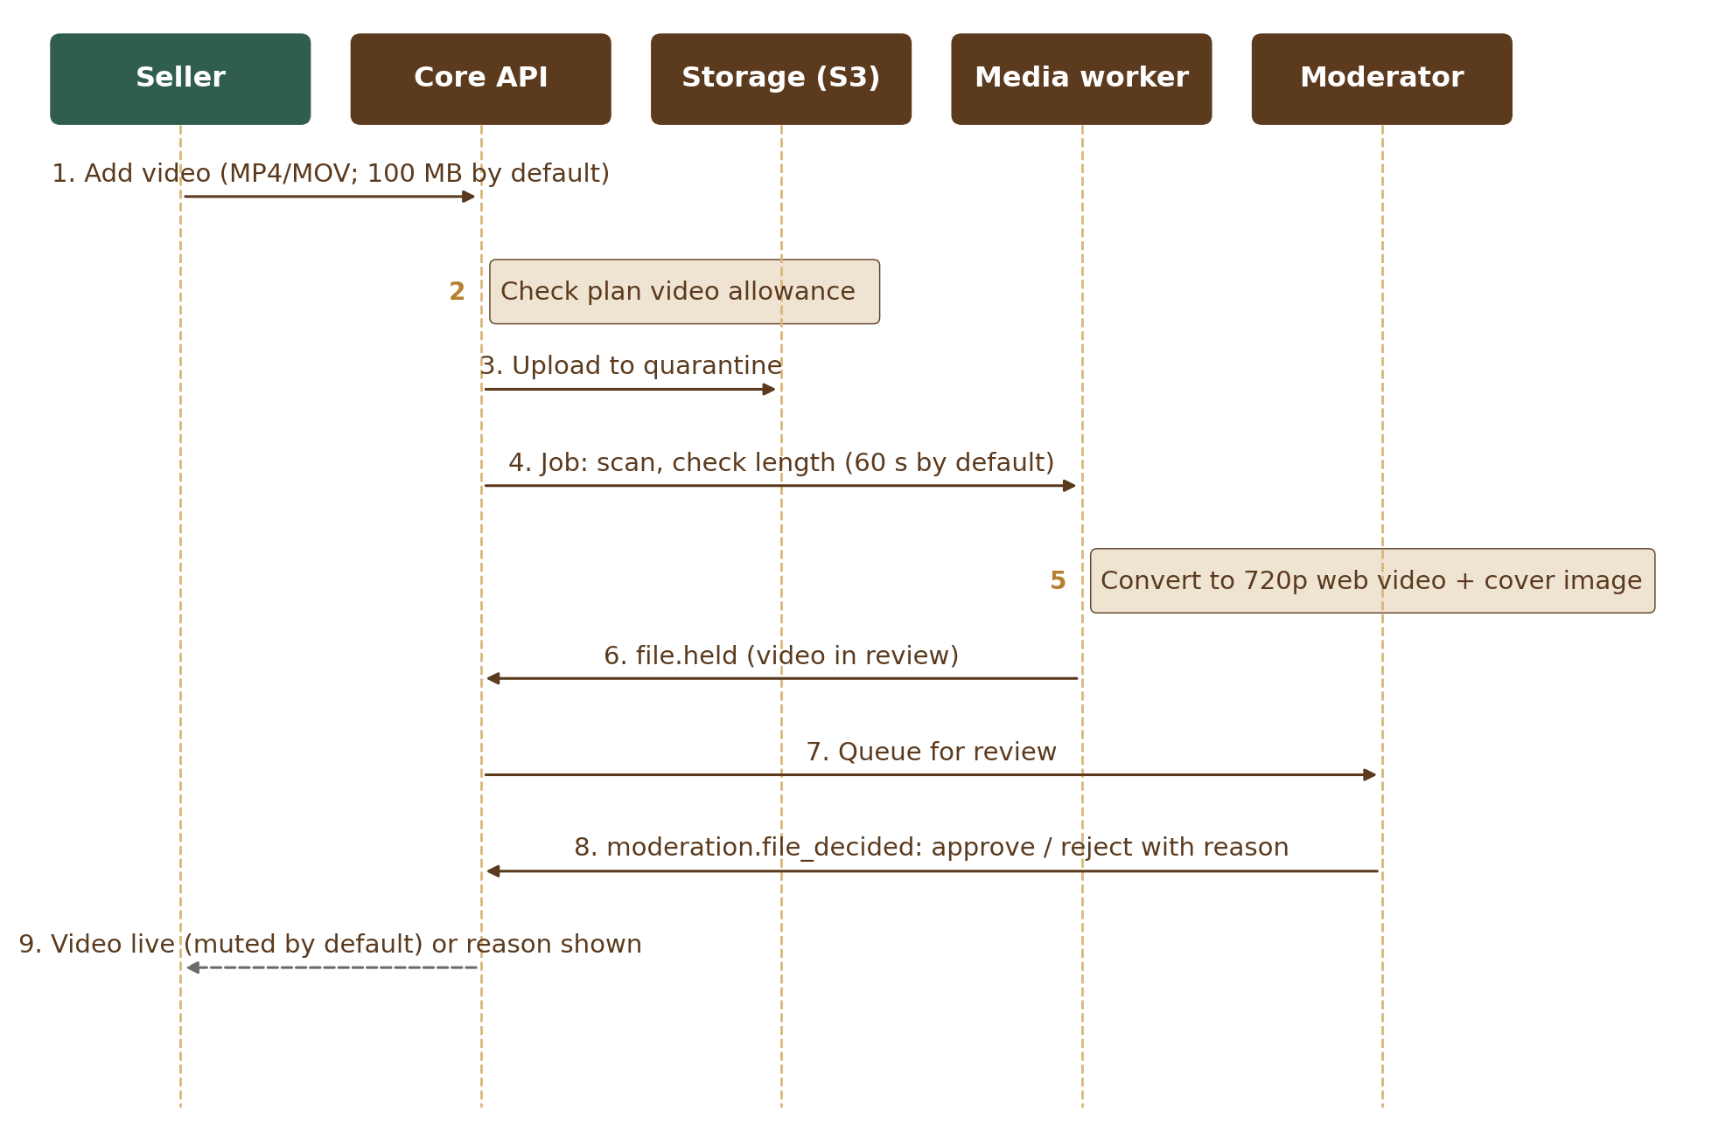
Figure 3 — Listing video sequence

2.1 File states
These are the values of `files.status` (M01-5 Section 2.1).
State | Meaning | Next
pending_upload | Slot issued, file not yet uploaded | uploaded / expired
uploaded | In quarantine, waiting for the confirm step | scanning / expired
scanning | Malware scan running | processing / rejected_infected
processing | Decode limits, conversion and photo safety checks running | ready / held (photo) / in_review (video) / failed
held | Photo contains contact details or a QR code; waiting for moderator | ready / rejected (moderation.file_decided)
in_review | Video waiting for moderator | ready / rejected (moderation.file_decided)
ready | Usable, not yet attached to a record | attached / deleted
attached | Linked to a record (listing, document, message, profile, page) | ready (detached) / deleted
expired | Never confirmed within 24 hours; object removed by the S3 lifecycle rule | — (row kept for 30 days, then removed)
deleted | Removed by the owner, by the 7-day cleanup of unattached uploads, or after its record was removed (listing.removed, document.deleted, message.deleted, account.closed); objects and variants deleted, CDN copies purged; skipped while a legal hold applies | — (row kept per retention policy)
rejected_infected, rejected, failed | Not usable; reason stored | —

A suspected copy (FIL-024) is not a state: the file keeps `ready` or `attached` and `files.duplicate_suspected` is set until Module 12 decides.

3. Internal Interfaces
Interface | Main operations
FileService | createUploadSlot(owner, purpose, type, size, side?) → file ID (side: front, back, selfie or page, set by the M03 / M06 form slot; the watermark choice comes from the owner’s preference) + pre-signed POST · complete(fileId) · attach(fileId, entity) · detach · getSignedLink(fileId, owner) (owner only) · streamForViewer(fileId, staff) (M03 watermarked viewer, audited) · getPublicUrls(fileId) · applyBlurBoxes(fileId, boxes, staff) (called by M03) · getLocation(fileId, staff) → coordinates and distance to the declared place (permission photo_location.view, audited). Moderation decisions come in through the event moderation.file_decided, not a call.
UnitService | listUnits(itemType) · convert(qty, from, to, state?) · helperPrices(metricPrice, unit, viewerCountry) · fromHelper(price, traditionalUnit) → metric price
CountryService | get(code) · regions(countryCode) · districts(regionCode) · status(code) · feature(code, name) · guidePrice(amount, currency, viewer) · ratesAsOf()
RateLimiter | check(group, keys) → allowed / retryAfter · register(module, limits) · block(key, minutes, reason)
ImageSafety | scan(fileId) → clean / held(reasons) · fingerprint(fileId) · findSimilar(fileId) · blockFingerprint(fileId, reason)
LocaleService | t(key, locale, params) · formatNumber(n, style) · formatMoney(amount, currency, style) · formatDate(ts, tz) · businessHoursBetween(a, b) · addBusinessHours(t, hours) (both skip Sundays and business_holidays)
UrlService | slugFor(entity) (the only way other modules read an address; M03 keeps no copy) · suggestAddress(businessName) → address or suggestions (transliteration) · checkAddress(address) (URL-002 rules, uniqueness, reserved_names) · checkBusinessName(name) (reserved_names) · onProfileRenamed(profileId, newName) → new address + permanent redirect · resolve(path) → entity or redirect
TradeTerms | upsert(groupId?, term, locale, kind) (called by M04) · retire(id) · synonyms(term) (read by M07)
AuditService | record(actor, action, target, before, after, reason) · search(query, viewer) (fields per role, M01-6 Section 12.9) · ownActions(agent, query) (field agents) · export(query, superAdmin) → CSV or JSON (formula-safe)
ConfigClient | get(key, default, context{account, role, plan, category, country}) · flag(name, context) · onChange(key, fn)
SimpleLists | items(groupKey, locale) → active items in display order with name and parent (cached; refreshed on config.published) · name(groupKey, tagKey, locale) → name, also for a retired item · isOffered(groupKey, tagKey) → true only for an active item (other modules check a new choice with it). Usage counts on the Simple lists screen come from the owning module (CFG-011)
ConfigService | createDraft(screen) · updateDraft(versionId, changes, rowVersion) · discard(versionId) · previewImpact(draftVersionId) → changes, affected counts, example (CFG-008) · submit(versionId, reason) · approve / reject(versionId, reason) · publish(versionId, at?) → version (now or scheduled) · cancelSchedule(versionId, reason) · rollback(toVersionId, reason) → new draft (CFG-009) · emergencyOff(switch, reason) (CFG-010) · history(scope) · export(versionId) · import(file) → draft. Publish runs only after approval (CFG-006) except the emergency path; every publish and rollback emits config.published. Endpoints: Section 4.2.
EventBus | publish(type, payload) inside a DB transaction · subscribe(type, handler)
Jobs | enqueue(kind, payload, runAt?) · schedule(name, cron) · rerun(jobId, staff) (failed jobs, audited)
Retention | registerPolicy(dataType, period, action, legalMinimum) · placeHold(scope, reason, reference) · releaseHold(id, reason) · holdCoverage(scope)
AIGateway | call(module, purpose, dataLevel, input) → output with AI label, or a refusal (blocked by data filter, over budget, provider error) — AIG-001 to AIG-005, Section 14

4. Public API Endpoints (v1)
Method & path | Purpose | Who
POST /v1/files | Create upload slot (returns file ID + pre-signed URL) | Signed-in users
POST /v1/files/{id}/complete | Confirm upload, start scan | Owner
GET /v1/files/{id} | File status, variants, warnings | Owner, permitted viewers
GET /v1/files/{id}/link | Signed link for a private document (FIL-009) | File owner only (audited); staff use the M03 watermarked viewer
DELETE /v1/files/{id} | Remove unattached file | Owner
GET /v1/units?itemType= | Allowed units and factors | Public
GET /v1/units/convert | Convert quantity / price | Public
GET /v1/i18n/{locale} | Translation bundle (cached) | Public
GET /v1/me/preferences · PUT | Language, number style, guide currency (or “Don’t show”), time zone with its source (`time_zone_source`: M02 writes country or browser at sign-up; this endpoint writes user — a zone chosen by the user is never replaced automatically), photo watermark default. The cookie choice is not here: it is recorded with POST /v1/consents | Signed-in users
GET /v1/business-names/check?name= · GET /v1/store-addresses/suggest?name= · GET /v1/store-addresses/check?address= | Check a business name against reserved names; suggest a web address made from the name (transliterated, or suggestions when the name is in another script); check an edited address (URL-002) | Signed-in sellers
GET /v1/me/activity?type= | Own account activity (audit subset), newest first; filter type: sign_in, change, document_view, agent_action. Sign-in rows show the city and country stored with the record (Section 6) | Signed-in users
GET /v1/me/allowances | Plan allowances of the account (e.g. video: used and total), read from Module 11 plan settings; shown by the video uploader (“Video: 1 of 2 used on your plan.”) | Signed-in users
/status/maintenance.json (CDN file) | Maintenance state: mode (off, full or read_only), the expected-back time and the start of an approved planned maintenance (for the notice banner). Module 1 writes this small file to the CDN each time platform.maintenance_mode or maintenance.expected_back_at is published or scheduled; the maintenance page and the banners read it, so they work while the API is down (no API call) (API-009) | Public
GET /v1/audit?actor=me | Own actions of a field agent (time, action, target; own records only, scope fixed by the server) for My actions in the agent app (M02-S20) | Field agents
POST /v1/consents | Record cookie choice (visitors may send an Idempotency-Key) | Anyone
GET /v1/countries | Country list with phone code, currency, address layout (cached) | Public
GET /v1/fx/guide-rates | Today’s guide rates and date (cached) | Public
GET /v1/lists/{groupKey}?locale= | Active items of a simple list (site_type, link_platform, capacity_unit, service_technique) in display order, with key, name and parent (cached) (CFG-011) | Public
GET /v1/admin/audit | Search audit log (role-scoped; fields per role, M01-6 Section 12.9) | Staff
POST /v1/admin/audit/export | Export audit records | Super Admin
GET /v1/admin/legal-holds · GET /v1/admin/legal-holds/{id} · POST /v1/admin/legal-holds · POST /v1/admin/legal-holds/{id}/release | List holds; place a hold (scope, reason, reference); release a hold (reason required). GET /v1/admin/legal-holds/coverage?scopeType=&scopeId= shows what a hold covers and what a release would let the next retention run delete (RET-004); audited | Super Admin, Admin (Moderator: list only, items under review)
POST /v1/admin/files/{id}/location | Show the kept photo location for checks: coordinates and the distance to the declared place, worked out on the server; reason and note required in the request body; every call audited with the reason (FIL-027) | photo_location.view (Moderator, Senior Moderator)
GET /v1/admin/rate-limit-blocks · POST /v1/admin/rate-limit-blocks · DELETE /v1/admin/rate-limit-blocks/{key} | List current blocks (automatic and permanent); block one key permanently (reason required; KEY_ALREADY_BLOCKED if it is blocked already); lift a block (reason required) (RTL-005). Screen: Blocks (M01-AD-15); every change audited with its reason | blocks.view · blocks.manage (Super Admin, Admin)
GET /v1/admin/fx-rates | Guide rates for staff: each guide currency with rate, base, rate date, source, age and state (up_to_date, old — last rates in use, guide_price_hidden) (CTY-005). Read only; shown on the Exchange rates tab of the Country table (M01-AD-03) | settings.view
POST /v1/admin/maintenance/start · POST /v1/admin/maintenance/end | Start maintenance now: mode (full or read_only), expected-back time (optional), reason — published at once as an emergency version, audited, alert to all Super Admins; a second Super Admin reviews it within 24 hours on M16-AD-01. End maintenance: note required, published at once, audited, no second approval (CFG-012). Planned maintenance is a normal draft of platform.maintenance_mode and maintenance.expected_back_at with a scheduled publish (Section 4.2) | platform.maintenance (Super Admin only)
GET /v1/admin/jobs?status=retrying|dead&kind=&module=&from= | List failed jobs with their last error (EVT-005). “Retrying” is not a stored status: it means status queued with attempts above 0; “dead” is status dead | Super Admin, Admin
POST /v1/admin/jobs/{id}/rerun · POST /v1/admin/jobs/rerun · POST /v1/admin/jobs/{id}/discard | Re-run one failed job (EVT-002); re-run up to 100 jobs of one kind (reason required); discard a dead job (reason required) (EVT-005); all audited — the reason is kept in the audit record only | Super Admin, Admin
GET /.well-known/security.txt | Security contact file (SEC-010) | Public
GET /v1/admin/audit/{id} | One audit record with before / after values and chain-check result (AUD-008); the view is recorded | Staff (role-scoped)
Settings screens | All settings endpoints (drafts, approval, publish, schedule, rollback, emergency path, export / import and each settings screen): Section 4.2 | —

Visitors (not signed in): language, number style and guide currency are kept in one first-party essential setting in the browser (cookie `ot_prefs`, 12 months) that holds only those three values. It has no identifier and is never used for tracking, so it needs no consent; it is copied to the account at sign-up or sign-in.

4.1 API rules for all modules
The platform middleware applies these rules to every module’s API (DevOps Standards, Section 9).
Rule | Design
Errors (API-002) | One format: `{ "error": { "code": "FILE_TOO_LARGE", "message": "<translated text>", "requestId": "…", "details": {…} } }`. Codes are listed in the OpenAPI contract.
Idempotency keys (API-005) | Writes that create records or charge money accept an `Idempotency-Key` header (a UUID made by the client). The middleware stores key, account, endpoint, a hash of the request and the first response in `idempotency_keys` for 24 hours and returns the stored response for repeats. Same key with a different request → 422 `IDEMPOTENCY_KEY_REUSED`; repeat while the first is still running → 409 `REQUEST_IN_PROGRESS`. Required for payments; accepted on all create actions. Visitors may send a key on `POST /v1/consents`; for them the key is stored with the visitor ID of the consent cookie (`caller_type` visitor, M01-5 Section 13.3).
Rate-limit headers (API-006) | Every response carries `RateLimit-Limit`, `RateLimit-Remaining` and `RateLimit-Reset` for the action group that applies; over the limit → 429 with `Retry-After` (seconds) and code `RATE_LIMITED` (Section 10).
Pagination (API-007) | Cursor-based: `?limit=` default 20, maximum 100; response `{ "items": […], "nextCursor": "…" }` (null on the last page). Cursors are opaque (sort key + ID); no page numbers or total counts on large lists.
Versions and deprecation (API-008) | Version in the path (/v1). An old version keeps working at least 6 months after its replacement; its responses carry `Deprecation` and `Sunset` headers with a link to the release notes, where the change is announced.

4.2 Settings API
Every settings screen uses these endpoints (M01-2 CFG-005 to CFG-010; M01-6 Section 12.1); the Configuration Console (M16) later adds only its own screens. A draft is a config version with status `draft`. Screen endpoints that create, edit or retire an item take `draftId` and change only that draft, so nothing is live until the version is approved and published. The Permission column uses the register names (M01-1 Section 6.3 (b)); the server also checks the two-level rule (the approver is not the editor; a Super Admin for a high-impact version). Every call is audited with its reason.
Method & path | Purpose | Permission
GET /v1/admin/config/versions?screen=&status= · GET /v1/admin/config/versions/{id} | Version history and compare: each version with its entries, status, people, times and reasons (CFG-009) | settings.view
POST /v1/admin/config/versions | Create a draft for one screen (empty, or copied from the published version) | settings.edit (ai_budget.draft for AI budgets)
PATCH /v1/admin/config/versions/{id} | Edit the draft’s entries and overrides; sends row_version; a stale save gets 409 EDIT_CONFLICT (CFG-007) | settings.edit
DELETE /v1/admin/config/versions/{id} | Discard an own draft (status draft only) | settings.edit
POST /v1/admin/config/versions/{id}/preview | Preview impact (CFG-008); required before sending | settings.edit
POST /v1/admin/config/versions/{id}/submit | Send for approval with a reason → waiting | settings.edit (ai_budget.draft for AI budgets)
POST /v1/admin/config/versions/{id}/approve · POST …/reject | Approve or reject with a reason → approved or rejected; the editor, or an Admin on a high-impact version, gets 403 APPROVER_NOT_ALLOWED (CFG-006) | settings.approve_high (high impact) · settings.approve_other (other)
POST /v1/admin/config/versions/{id}/publish | Publish an approved version now (ConfigService.publish; emits config.published) → published | settings.publish
POST /v1/admin/config/versions/{id}/schedule · DELETE …/schedule | Set `scheduled_for` on an approved version → scheduled; cancel a scheduled version with a reason → cancelled (CFG-009) | settings.publish
POST /v1/admin/config/versions/{id}/rollback | Make a new draft with the values of this earlier version (reason required); it needs approval like any change; when it is published, the version it replaces becomes rolled_back (CFG-009) | settings.edit
POST /v1/admin/config/emergency | Emergency path: switch a production feature OFF or turn under-attack mode ON at once (reason required, kept as the version’s submit_reason); published at once, audited, alert to all Super Admins (CFG-010) | settings.emergency_off
POST /v1/admin/config/emergency/{versionId}/review | Second Super Admin review within 24 hours, done on the Changes screen (M16-AD-01): confirm, or open a follow-up draft (CFG-010) | settings.approve_high
POST /v1/admin/config/export · POST /v1/admin/config/import | Export a published version as a file (staging); import a file as a draft (production) that needs approval (ENV-008) | settings.view (export) · settings.edit (import)
GET /v1/admin/settings · PATCH /v1/admin/settings/{key} · POST /v1/admin/settings/{key}/overrides · DELETE …/overrides/{scope} | Settings editor (M01-AD-01): value, default, level and override count per setting; edit a value; add or remove an override (CFG-004). Only keys in the settings register exist (M01-2 Section 18) | settings.view · settings.edit
GET /v1/admin/switches · PATCH /v1/admin/switches/{name} · POST …/{name}/retire · GET …/{name}/check?account= | Feature switches of this environment (M01-AD-02): edit state, targets and overrides; retire an unused switch (reason, approval); new switches come only with code releases (a developer adds them); check which rule decides for an account (CFG-003, CFG-005) | settings.view · settings.edit
GET /v1/admin/countries · PATCH /v1/admin/countries/{code} · POST /v1/admin/countries/{code}/regions · PATCH /v1/admin/regions/{code} · POST /v1/admin/regions/{code}/districts · PATCH /v1/admin/districts/{code} · POST …/retire (regions, districts) | Country table (M01-AD-03): country tabs, states and regions, districts (CTY-001, CTY-002, CTY-008) | settings.view · settings.edit
GET /v1/admin/reserved-names · POST /v1/admin/reserved-names · PATCH …/{id} · POST …/{id}/retire · GET …/matches?name= | Reserved names (M01-AD-04); existing business names and store addresses that match a new name (URL-008, URL-009) | settings.view · settings.edit
GET /v1/admin/holidays?country=&year= · POST /v1/admin/holidays · PATCH …/{id} · POST …/{id}/retire · POST /v1/admin/holidays/import | Holiday calendar (M01-AD-05); a year file is refused whole if any row is wrong (LOC-012, LOC-013). Staff type the English name; the server makes the key (e.g. holiday.diwali) and stores the English text in translations; other languages are added in the translation store (M17) | settings.view · settings.edit
GET /v1/admin/rate-limits · PATCH /v1/admin/rate-limits/{module}/{group} · POST …/overrides · DELETE …/overrides/{scope} | Rate limits (M01-AD-06); limits registered in code can be changed, not removed (RTL-002) | settings.view · settings.edit
GET /v1/admin/ai/usage?month= · GET /v1/admin/ai/budgets · PATCH /v1/admin/ai/budgets/{id} | AI usage and budgets (M01-AD-07): calls, tokens, cost against budget, alert and pause state; edit a budget, its alert levels and whether it is essential (AIG-004, AIG-006). A past month shows the spend from ai_requests against the budget of the settings version that was live in that month | settings.view · settings.edit or ai_budget.draft
GET /v1/admin/retention-policies · PATCH /v1/admin/retention-policies/{dataType} | Retention policies (M01-AD-11) with legal minimum, last run result (retention_run_results) and hold counts (legal-hold scopes mapped to data types, M01-5 Section 10.2); a period below the legal minimum gets 422 BELOW_LEGAL_MINIMUM (RET-005) | settings.view · settings.edit
GET /v1/admin/units · POST /v1/admin/units · PATCH …/{code} · POST …/{code}/retire · GET /v1/admin/units/land · POST /v1/admin/units/land · PATCH …/land/{unit}/{region} · POST …/land/{unit}/{region}/retire · GET /v1/admin/units/helper · PATCH /v1/admin/units/helper/{country} | Units, factors and usage counts; state land units with their source; helper units per viewer country (“other” level) (M01-AD-12; UNT-001, UNT-008, UNT-009); a unit used by live listings cannot be retired | settings.view · settings.edit
GET /v1/admin/simple-lists · GET /v1/admin/simple-lists/{groupKey} · PATCH /v1/admin/simple-lists/{groupKey} · POST …/{groupKey}/items · PATCH …/items/{tagKey} · POST …/items/reorder · POST …/items/{tagKey}/retire | Simple lists (M01-AD-14): groups with item counts; items with names, order, parent and usage counts; rename a group; add, rename, reorder, set a parent and retire items (reason required to retire). A parent in a group that does not allow parents gets 422 PARENT_NOT_ALLOWED; retiring a parent with active items gets 422 ITEM_HAS_CHILDREN; a key already in the group gets 409 KEY_TAKEN (CFG-011) | settings.view · settings.edit

Version status moves (M01-5 Section 8.1; M01-6 Section 12.1): draft → waiting → approved or rejected; approved → published, or scheduled → published or cancelled; a published version becomes rolled_back when a rollback version replaces it. Submit, approve, reject, cancel and rollback each need a reason.

4.3 Error codes
Codes use the error format of Section 4.1 and are listed in the OpenAPI contract. The message is the translated text the user sees (M01-6).
Code | HTTP | Message shown
FILE_TYPE_NOT_ALLOWED | 415 | “This file type isn’t supported.”
FILE_TOO_LARGE | 413 | “Photo is larger than {max} MB.” / “Video is larger than {max} MB.” / “File is larger than {max} MB.”
VIDEO_TOO_LONG | 422 | “This video is {length}. Please trim it to {max} seconds or less.”
UPLOAD_ALLOWANCE_USED | 403 | “Upgrade your plan to add video to more listings.”
NOT_VERIFIED | 403 | “Only verified sellers and farmers can add video. Get verified first.”
FILE_INFECTED | 422 | “We couldn’t use this file: our safety scan found a problem. Please upload a different file.”
EDIT_CONFLICT | 409 | “Changed by someone else — please reload.”
APPROVER_NOT_ALLOWED | 403 | “You made this change, so another person must approve it.” / “This change is high impact. A Super Admin must approve it.”
REASON_REQUIRED | 400 | “A reason is required.”
BELOW_LEGAL_MINIMUM | 422 | “Period is shorter than the legal minimum.”
NAME_RESERVED | 422 | “This name is reserved. Please choose another.”
ADDRESS_TAKEN | 409 | “This web address is taken. Try {suggestion}.”
COUNTRY_BLOCKED | 451 | “OudhTrade isn’t available in your country.”
RATE_LIMITED | 429 | “You’re doing this too often. Please try again in {time}.”
MAINTENANCE | 503 | “OudhTrade is being updated. Expected back: {time}.” (no time when it is empty); with Retry-After (API-009)
READ_ONLY_MODE | 503 | “OudhTrade is in read-only mode until {time}. You can look around, but changes are paused.” (API-009)
KEY_ALREADY_BLOCKED | 409 | “This key is already blocked.”
IDEMPOTENCY_KEY_REUSED | 422 | “This request was already sent with different details. Please start again.”
REQUEST_IN_PROGRESS | 409 | “We’re still working on your last request.”
PARENT_NOT_ALLOWED | 422 | “Items in this list can’t have a parent.”
ITEM_HAS_CHILDREN | 422 | “This item has {n} active items under it. Retire or move them first.”
KEY_TAKEN | 409 | “An item with this key already exists in this list.”

5. Events and Jobs
Event names follow the platform event catalogue; the full list of events, publishers and users is in HLD Appendix B.
Event / job | Emitted or run by | Used by
file.ready | MediaService | Profiles and verification (M03), Listings (M05), Documents (M06), Chat (M09), Moderation (M12), Notifications (M13)
file.held (photo held, video in review, suspected copy — a suspected copy keeps its status) | MediaService, ImageSafety | Profiles and verification (M03), Listings (M05), Documents (M06), Chat (M09), Moderation (M12) review queue, Notifications (M13)
file.rejected | FileService | Profiles and verification (M03), Listings (M05), Documents (M06), Chat (M09), Moderation (M12), Notifications (M13)
config.published | ConfigService (after an approved publish from M16) | All modules (settings cache)
legal_hold.placed / legal_hold.released | RetentionEngine | Retention (M01 RetentionEngine), Identity & Security (M02), Profiles and verification (M03), Moderation (M12)
fx.rates_updated | CountryService | Listings and search caches
security.rate_block | RateLimiter | Monitoring, Moderation
job: file.scan / file.process / video.transcode | FileService | Workers
schedule: uploads.cleanup (hourly) | Scheduler | FileService
schedule: retention.run (daily 02:00 IST) | Scheduler | RetentionEngine
schedule: audit.seal (every 5 minutes) · audit.verify (daily) · audit.archive (daily) | Scheduler | AuditService
schedule: sitemaps.build (daily) | Scheduler | UrlService
schedule: users.quarterly_notice | Scheduler | Notifications (IT Rules 2026)
schedule: fx.fetch (daily 06:00 IST) | Scheduler | CountryService
schedule: ai.budget_check (hourly) | Scheduler | AIGateway
schedule: idempotency.cleanup (hourly) | Scheduler | Platform middleware
schedule: refs.orphan_check (nightly) | Scheduler | FileService, UrlService, AuditService, RetentionEngine (shared-link check)

5.1 Events Module 1 reacts to
Event (from) | What Module 1 does
account.created (M02) / enquiry.created (M09) | Add one to the cookie-free sign-up or enquiry count of the day and country (CKE-007); no personal data kept
account.closed (M02) | Sent when the 30-day closure grace ends; at once: anonymise user_preferences and cookie_consents; delete the account’s unattached uploads; retire or redirect its store address; audit records are kept
listing.published / listing.updated / listing.removed (M05) | Add, update or remove the page in the sitemaps; on removal detach and retire the listing’s files (public variants removed from CDN) and redirect or retire its page address
profile.renamed (M03) | UrlService makes the new web address from the new business name (URL-002), keeps it as the one current address in url_slugs and redirects the old address permanently; the old address is reserved for 12 months (configurable). M03 changes only the name
document.deleted (M06) / message.deleted (M09) | Detach the file and delete it when no longer needed
moderation.file_decided (M12) | Approve → file ready (video live); reject → file rejected with reason; copied, stock or banned photos added to image_blocklist
content.taken_down (M12) | Place a system legal hold on the target (placed_by empty = system), so its files and records are kept for evidence; purge the target’s public photos and video from the CDN cache; the takedown is kept in the audit trail of the target
plan.changed (M11) | Refresh the account’s plan-based allowances (video allowance, upload limits) and plan-scoped settings
config.published (M01 ConfigService) | Every instance refreshes its settings cache

Outbox relay polls new events (or uses database notifications) and delivers to handlers; each handler stores processed event IDs to stay idempotent. Jobs use a database table with `SKIP LOCKED` style claiming, exponential back-off (1 min → 2 h, 8 attempts) and a dead-letter state (status `dead`). Staff retry or discard failed jobs on the failed jobs screen (M01-6 Section 12.11); a discarded job keeps its row with status `discarded`. Each job stores its owner module and first failure time (M01-5 Section 9.3). No personal data in job errors: `last_error` holds a short error code and the request ID only, with personal data removed before it is saved; the failed jobs screen shows only IDs from the payload (e.g. file or account ID) and a “View account” link to account lookup (M02-AD-01), which checks its own permission and records the look-up.

6. Audit Log Design
- Append-only table; the application database user has INSERT and SELECT only (no UPDATE / DELETE).
- Each record is written in the same transaction as the action (AUD-003), without its hash, so busy writes never wait on each other.
- Hash chain: a sealing job (`audit.seal`, every 5 minutes) reads unsealed records in id order and fills `hash` (SHA-256 of the record content plus the previous hash) and `prev_hash`. It runs as its own database user that may only fill empty hash columns (column privilege plus a trigger that refuses any other change). Each monthly partition is one chain: its first record starts from the last hash of the previous month; when a month closes, its last hash (the seal) is written to the locked archive.
- Daily check: `audit.verify` recomputes the chain of the current and the previous month and compares each closed month’s seal with the archive; any break alerts on-call and the tech lead. The audit log viewer shows the latest check result on each record (AUD-008; M01-6 Section 12.9).
- Each `audit.verify` run is stored in `audit_verify_runs` (month, checked at, result, first broken record); the viewer reads the result from there.
- Sign-in place: when a sign-in is recorded, the server looks up the IP address once and stores only the city and country (`geo_city`, `geo_country`) with the record; no exact location is kept. Account activity shows these values.
- Nightly export to S3 with Object Lock (compliance mode, 7 years).
- Search is scoped by the viewer’s role (see M01-2 AUD-005), and the fields shown depend on the role (M01-6 Section 12.9); field agents read only their own actions through `GET /v1/audit?actor=me`. Every search writes its own audit record.
- Exports (Super Admin only) are CSV or JSON. In CSV, any cell starting with =, +, -, @ (or a tab or carriage return) is prefixed with an apostrophe, so a spreadsheet program shows it as text and never runs it as a formula.
- Personal data in before / after values is limited to what is needed; ID numbers are masked.

7. Units, Locale and URL Details
- Units: prices are stored per metric or count unit only; factors stored as exact decimals; conversions use decimal arithmetic (no floating point for money). Helper prices (tola, mithqal, seer, maund) are calculated at display time from the metric price, per category and viewer country. Tola resolves by item type: weight for wood / chips / powder, volume for oil. Bigha / katha need a state; missing factor → unit not offered.
- Guide price: amount × rate of the day, rounded to 2 significant figures (e.g. ≈ AED 270, ≈ JPY 11,000; UNT-006), labelled “≈ … (guide only)”; not shown if rates are older than 48 hours; never stored on the listing.
- Locale: number style from user preference, default by account country (India → Indian); amounts in words (lakh / crore or K / M); dates “DD Mon YYYY”; IST business-hour calculator (Mon–Sat 09:00–19:00, LOC-006) used by all service-level timers. Legal complaint timers count calendar hours and do not use it.
- Holiday calendar (LOC-012): the calculator skips dates in `business_holidays` (Admin-managed in the holiday calendar screen, M01-6 Section 12.6, or moved from staging by export / import; India national holidays at launch, loaded each year before 1 January). The list is cached and refreshed on config.published; a timer started before a holiday is added is recalculated on its next check.
- URLs: slug = lower-case transliterated title words + “-” + listing number; resolution by number, so old slugs still work and 301-redirect to the current one. Store web address (URL-002): made from the business name — lower case, transliterated to a–z (e.g. Arabic, Devanagari or Chinese letters), spaces and other characters turned into hyphens, cut to 40 characters; if the result is shorter than 3 characters, taken or reserved, the seller gets up to three suggestions (e.g. with the city or a number added) and may type an address within the rules. `url_slugs` is the only store; M03 keeps no copy and reads it with `slugFor`. One business-name rename per 90 days (M03 rule; the storefront shows “Formerly {name}” for 90 days); old name redirects permanently and cannot be claimed by others for 12 months. Redirect targets are internal paths only (they must start with a single “/”, no scheme or host), so an address can never send a visitor to another site.
- Reserved names (URL-008): business names and page addresses are normalised (lower case, transliterated, look-alike characters folded, e.g. 0 → o, 1 → l) and checked against `reserved_names`: reserved words (admin, api, help, oudhtrade, sign-in…) and banned words match exactly (the whole name or address); protected brand names of 5 or more characters also match as part of a name (“contains”). Admin manages the list in the reserved-names screen (M01-6 Section 12.5), which lists matching existing business names and page addresses before approval (URL-009). A new entry never renames an existing store; each match found before approval or by the nightly check is reported to Module 12 as a moderation case of type `reserved_name_match`.

8. Configuration, Security and Performance
Area | Design
Configuration | Values read from the current published version; cached in memory and Redis; refreshed on config.published or within 60 s; safe defaults in code; overrides resolved in order account list → role → plan → category → country → global — most specific wins (CFG-005).
Publishing (CFG-006) | One approval rule: settings change only through ConfigService.publish, called by the Configuration Console (M16) after approval. The settings screens follow the common settings pattern (M01-6 Section 12.1); approved settings can also move from staging by export / import (ENV-008), and the imported draft goes through the same publish step and approval. Every version needs a second person’s approval, at two levels: high-impact settings need a Super Admin who is not the editor; other settings need any other Admin who is not the editor. The rule is kept in M01-6 Section 12.1 (the one source) and each setting’s level in the settings register (M01-2 Section 18); ConfigService checks the approver’s role and that the approver is not the editor. Admin-managed tables (units, area_unit_factors, countries, reserved_names, business_holidays, retention_policies, rate_limit_policies, ai_budgets) change the same way: the draft is stored as a config version and applied by ConfigService.publish. Before approval, previewImpact shows what changes, who is affected and an example (CFG-008). An approved version is published at once or at its scheduled time (config_versions.scheduled_for; a scheduler job publishes it); a rollback to any earlier version is a new draft that needs the same approval (CFG-009). Every publish and rollback creates a version, is audited with its reason and emits config.published. Records edited by staff carry row_version; a save on a record changed by someone else is refused (CFG-007). Emergency path (CFG-010): `emergencyOff` publishes one version at once, without approval, that only switches a production feature OFF or under-attack mode ON; it needs settings.emergency_off and a reason, is marked is_emergency, is audited and alerts all Super Admins; a second Super Admin reviews it within 24 hours (an overdue review alerts again). Switching back uses the normal approval. The endpoints are in Section 4.2.
Feature switches | Evaluated per request with context (release, environment, role, plan, category, country, account list); each environment has its own console and switch values; switches move between environments by export / import; changes logged.
Maintenance mode (CFG-012, API-009) | A gate in the API middleware reads platform.maintenance_mode on every request (cached; refreshed by config.published). Full: every user, app and partner call gets 503 MAINTENANCE; staff calls pass only for Super Admins. Read-only: every change (POST, PUT, PATCH, DELETE) gets 503 READ_ONLY_MODE, except sign-in and incoming provider callbacks (payments, messages), which are accepted and queued; staff calls pass only for Super Admins. Workers and the Scheduler read the mode before taking a job: in full maintenance they wait, and queued work runs when it ends; in read-only they keep running. The CDN serves the maintenance page and banners from /status/maintenance.json when the API is down.
Exchange rates (CTY-005) | If the daily fetch fails, the last rates stay in use; an alert fires after 24 hours without new rates and the guide price is hidden after 48 hours.
Security | Private bucket for originals and documents; public bucket only for processed photo / video variants; KMS encryption; signed URLs; upload size enforced by storage; content-type checked by file signature; image decode limits; scanning before use; photo safety checks; rate limits on all endpoints (Section 10).
Performance | Photo processing < 10 s P95; video processing < 5 min P95; unit and translation responses cached at CDN / memory; audit search < 3 s for 30 days of data.
Monitoring | Metrics: upload success rate, scan failures, processing time, held and duplicate photos, job backlog age, outbox lag, retention counts, rate-limit blocks, exchange-rate age; synthetic speed checks from Mumbai, Dubai and Singapore and real-user monitoring (OBS-009, no cookies or identifiers); AI spend against budget; alerts routed to on-call. Alert levels are starting values kept as settings (M01-1 Section 6.3 (d); M01-2 Section 18) and reviewed by M18.
Logs (OBS-003, OBS-007, OBS-008) | Application logs: 30 days searchable, then archived for 1 year. Personal-data processing logs (who read or changed personal data, AI calls with personal data): at least 1 year in a locked log archive (S3 Object Lock). Security logs: at least 180 days. All logs stay in India (Mumbai, copies in Hyderabad); application logs hold IDs, not personal data.
KPI counts (CKE-007) | Page views, listing views, enquiries and sign-ups are counted on the server from requests and events, without cookies or personal identifiers (counters per page, day and country in Redis). Module 1 only counts; M18 stores the daily totals (kpi_daily). They work for visitors who reject analytics cookies; detailed analytics still needs consent.
White-label (ENV-012) | No brand name, colours or logos in code: the brand comes only from design tokens and configuration (name, domain, logo files, email sender, legal entity).
Cost controls | AWS Budgets with alerts at 50 %, 80 % and 100 % of the monthly budget (amount in OBS-005); cost anomaly detection; cost tags per service; lifecycle rules move old originals to cheaper storage after 90 days; video limited to one per listing and plan allowance.

9. Environments and Pipeline
- Separate AWS accounts for development, staging and production under one AWS Organization; all resources defined in infrastructure-as-code.
- Pipeline (DevOps Standards, Sections 4.3 and 8): lint → unit tests → coverage check → API contract tests (against the OpenAPI contract) → secret scan → dependency and container scans → accessibility check (screens) → module-boundary check (code may query only its own schema) → staging migration → staging deploy → end-to-end tests → approval → production migration (versioned scripts; tool per team proposal) → production deploy (zero downtime) → table diagrams generated from the real schema.
- Database users created by infrastructure code: app_runtime, app_migrator (pipeline only), app_readonly (read replica and reporting views) and a named, time-limited break-glass user (Master Database Design, Section 8.4).
- Development and staging use made-up data only — a seed script and the demo data set. Production data is never copied to them, not even anonymised. Messages go to a test inbox; payments in test mode.
- Secrets in AWS Secrets Manager; no secrets in code or pipeline logs.
- Each release produces a software bill of materials and signed container images; production accepts only signed images (DevOps Standards 10).
- AWS account security: CloudTrail organisation trail (all regions) to a locked log bucket; GuardDuty threat detection and Security Hub with the CIS AWS Foundations Benchmark in every account; critical findings alert on-call.

9.1 Backups, standby and disaster recovery
Area | Design
Backups (ENV-009) | Continuous database backup with point-in-time restore (window in ENV-009); daily snapshots copied to Hyderabad; S3 versioning and cross-region replication to Hyderabad; audit archive under Object Lock (7 years). The Keycloak database (its own small RDS instance) has its own backups.
Warm standby (ENV-010) | Mumbai: PostgreSQL Multi-AZ with automatic failover (RPO 5 minutes in the region). Hyderabad: a cross-region read replica of the main database, a few seconds behind, with no user traffic; region-loss data loss target ≤ 1 minute. Keycloak database: cross-region replica in Hyderabad.
Region failover | Promote the Hyderabad replica; create the containers from infrastructure code; promote the Keycloak replica; rebuild the Typesense index from PostgreSQL; start Redis empty (caches refill); point DNS to Hyderabad. RTO 24 hours in R1, 8 hours from R2. Year 2 option: the Hyderabad copy may serve search or reports.
DR plan | Written plan with steps, contacts and checks; owner: tech lead; reviewed after every drill.
Drills (ENV-011) | Quarterly: restore a production backup (Hyderabad copy) into an isolated AWS account, time RPO and RTO, then delete the copy. Yearly: region failover drill (promote the standby in a test). Results reported to the founder and tech lead.

10. Rate Limits
Token-bucket counters in Redis, checked by the platform middleware before the request reaches a module. Defaults below are settings (configurable, with overrides by plan, role and country). Later modules add their own rows in their document 3. A signed-in user is always counted by account, never by IP, so many users behind one office or mobile-network IP do not block each other; visitors are counted by IP / device, with limits set generously for that reason. A visitor always gets a challenge before any block.
Action group | Key | Default limit | On breach
Public API calls without an account (default) | Visitor IP / device | 360 per minute | Wait message; repeated → challenge
Browse public pages | Visitor IP / device (signed in: account) | 360 per minute | Challenge; then block (rate_limit.block_minutes, 15 by default)
Listing and store page views (anti-scraping) | Visitor IP / device (signed in: account) | 1,800 per hour | Challenge; security event; block only after a failed challenge
Search | Visitor IP / device · account | 180 per minute (visitor) · 60 per minute (account) | Friendly wait message
Photo upload | Account | 100 per hour, 300 per day | Wait message
Document upload | Account | 20 per day | Wait message
Video upload | Account | 5 per day (and plan allowance) | Wait message
Signed document links | Account (file owner) | 60 per hour | Security event
Business-name check | Account | 30 per minute | Wait message
Cookie consent write | Visitor IP / device | 30 per minute | Ignore extra
All other API calls | Account | 300 per minute | Wait message
Staff (Admin app) | Staff user | 600 per minute | Security event
Verified search-engine crawlers | Crawler (verified by reverse DNS) | 10 per second | Slow down (429)
Partner API keys (later) | API key | Per agreement | Wait message

Stored as (M01-5 Section 8.3): key types ip, device, account, plan, api_key, staff_user and crawler; “On breach” is an ordered list of steps (wait, challenge, slow_down, ignore, block, security_event), e.g. wait → challenge for “Wait message; repeated → challenge”. The block step lasts rate_limit.block_minutes (default 15; set on the Rate limits screen).
Staff, partner keys and verified crawlers have their own limits. A crawler that claims to be a search engine is verified by a reverse DNS lookup of its IP address and a forward lookup that must match (e.g. *.googlebot.com); unverified crawlers get visitor limits. Responses carry the `RateLimit-*` headers; over the limit → HTTP 429 with `Retry-After` and the standard error body (`code: RATE_LIMITED`). Blocks are written to the audit log as security events.

11. Edge Security Design
- AWS WAF on CloudFront: AWS managed rule groups (common rule set, known bad inputs, SQL injection, IP reputation, anonymous IP where needed), Bot Control, rate-based rules as a first line; geo-match rule blocks countries with status “blocked” (synced from the Country table on each publish).
- Denial of service: AWS Shield Standard; “under attack” mode (stricter WAF rules and challenges) behind a feature switch.
- Headers: HSTS (1 year, include sub-domains), Content-Security-Policy (own domains, approved analytics only after consent), frame-ancestors none, X-Content-Type-Options nosniff, Referrer-Policy strict-origin-when-cross-origin, Permissions-Policy (camera only on upload pages).
- Cookies and requests: Secure, HttpOnly, SameSite=Lax; CORS allow-list of OudhTrade domains; CSRF tokens on form posts.
- Keys and secrets: KMS customer-managed keys with yearly rotation; Secrets Manager rotation every 90 days for database and provider credentials where supported.
- Time: AWS Time Sync Service (traceable to UTC) for AWS-managed containers; NIC / NPL time servers where hosts are self-managed; counsel confirms this meets CERT-In (C11).
- Incidents: CERT-In incident runbook with a 6-hour reporting timer and named point of contact.
- Security contact (SEC-010): `/.well-known/security.txt` (contact, policy link, expiry date, languages) and a “Report a security issue” page from R1; text written by M17, published by M01.
- Status page: hosted by a separate provider outside the main AWS account so it stays up during an outage.

12. Country & Currency Design
- Country table and regions are configuration data published from Module 16 and cached; `GET /v1/countries` serves the public subset.
- Exchange rates are fetched daily at 06:00 IST from the approved provider [TBC: provider] for the guide currencies, stored in `fx_rates` with source and date; failures retry hourly and alert after 24 hours.
- Viewer country comes from the account (signed in) or CDN country header (visitors); guide currency from the Country table, changeable by the viewer.
- Sign-in settings per country (CTY-008): the Country table also holds `otp_channels` (the order in which one-time codes are sent, from the values sms, whatsapp, email and voice; e.g. India {sms, voice, whatsapp, email} — voice is used for voice-call codes in Hindi, Assamese, Bengali and English when needed; China SMS then email; WhatsApp then SMS then email elsewhere), `signin_methods` (password, google, apple, passkey), `sms_sender_registered` and `otp_daily_cost_cap` (0 for countries not open for sign-up). The global daily cap for all countries together is the setting `otp.global_daily_cost_cap`; alerts at 80 % of any cap go to Finance and on-call. CountryService exposes them through its interface; Module 2 reads them for every code it sends and every sign-in screen it shows, so a published change applies without a deploy.

13. Threat Model (STRIDE)
Threats to the platform services Module 1 builds, with the control that stops each one (NFR, Security & Compliance 6.3).
Threat type | Example threat | Control | Tested by
Spoofing (pretending to be someone) | Attacker completes another user’s upload, or uses a stolen staff session in Admin | Upload slots bound to the account and short-lived; staff single sign-on with 2-step sign-in; Admin only via VPN / IP allow-list | M01-7 security tests, VAPT
Tampering (changing data) | File swapped after scanning; audit records edited; configuration changed without approval | Scanned object locked by checksum; hash-linked audit log with Object Lock; configuration versions need approval and are audited | M01-7 security tests
Repudiation (denying an action) | Staff member denies a takedown or configuration change | Every staff action audited with actor, reason, before and after | Audit log checks
Information disclosure (leaking data) | Private document link shared; photo location revealed; seller contacts scraped | 5-minute signed links; photo metadata removed; anti-scraping and rate limits; contact-detail checks in photos | M01-7 security tests, VAPT
Denial of service (overloading) | Upload floods, very large videos, bot traffic | Rate limits, size caps, WAF and Bot Control, job queues with limits, cost alerts | Load and spike tests
Elevation of privilege (extra rights) | Changed role in a request; configuration override used to unlock plan features | Permissions checked on the server for every action; module boundaries; high-impact settings need a second person’s approval (CFG-006) | API tests per role
Denial of service (decompression bomb) | A small image that expands to billions of pixels (“pixel flood”), or a slow HEIC file | Header read first; pixel and side limits; decoding in a separate process with memory cap and time-out | M01-7 security tests
Spoofing (open redirect) | An old address in url_redirects made to point to an outside site and used in phishing | Only internal paths allowed as redirect targets (single leading “/”, no scheme or host); target built from the record, never from request input | M01-7 security tests
Tampering (CSV formula injection) | A user types “=HYPERLINK(…)” in a field that later appears in an audit export opened in a spreadsheet | Cells starting with = + - @ (or tab / return) escaped in CSV exports | M01-7 security tests
AI prompt injection and data leakage | Listing text tells the AI to ignore its rules or reveal data; personal data sent to an AI provider | AI gateway filters Restricted data and contact details before sending; fixed system prompts; AI output treated as untrusted (escaped, checked, never acts by itself); staff decide | M01-7 AI gateway tests
Agarwood-specific abuse | Copied photos of another seller’s oud; phone numbers or QR codes in photos to bypass messaging | Photo fingerprints; text and QR checks hold the photo for review | M01-7 photo safety tests

14. AI Gateway Design
Every AI call from any module goes through one AI gateway inside the Core API (AIG-001; HLD Section 9). No module calls an AI provider directly; the module-boundary check blocks provider libraries outside the gateway. Module 1 owns the gateway and its two tables, `ai_requests` and `ai_budgets` (M01-5 Section 13).
Part | Design
Interface | `AIGateway.call(module, purpose, dataLevel, input)` returns the output with its AI label and a request ID, or a refusal: blocked by the data filter, over budget, or provider error. Each purpose (e.g. M07 search_embedding, M12 moderation_assist, M05 listing_assistant, M17 help_assistant) is registered in configuration with its highest allowed data level, provider, model, time-out and whether it is essential.
Provider adapters | One adapter per provider with the same input and output shape; provider and model are chosen per purpose in configuration and can be switched without a code change. Only providers listed in the cross-border register (NFR) can be configured; an India-hosted model is preferred where quality is similar [TBC: provider].
Data filter (AIG-002) | Runs before anything is sent. Restricted data (ID and document numbers, verification documents, photo location, passwords, keys, audit log) is never sent, with one exception (PRD-AI-006; HLD Section 9; NFR Section 6.5): the text of a foreign-language verification document may be sent for translation for the reviewer (an M03 purpose) only after ID and document numbers are removed; images of IDs and selfies are never sent; contact details (phone, email, UPI ID, web addresses) are removed with the same patterns as the photo safety check; other personal data is sent only when the purpose allows it, and minimised (e.g. names replaced by placeholders). The declared data level (public, internal, confidential) is checked against the purpose’s limit. If blocked data cannot be removed, the call is refused.
Logging (AIG-003) | One `ai_requests` row per call: module, purpose, provider, model, tokens in and out, cost, data level sent, result status and time. Prompt and output text are not stored (a hash only). Calls with personal data also count as processing-log entries (OBS-007).
Budgets and alerts (AIG-004) | `ai_budgets` holds a monthly cost limit per module and purpose. Spend is counted per call in Redis and reconciled hourly from `ai_requests`. Alerts at 80 % and 100 % to the tech lead and product owner; at 100 % non-essential purposes pause (the feature falls back to its non-AI behaviour) until the next month or a raised budget approved on the AI usage and budgets screen (M01-6 Section 12.8, AIG-006); essential purposes continue and alert.
Labels and safety (AIG-005) | AI output shown to users carries a label (e.g. “AI suggestion”), returned by the gateway and shown by the screen. Output is treated as untrusted: escaped, length-checked, checked for contact details, never run as code or instructions. The model gets no tools that change data. AI never approves, bans, verifies or changes trust by itself (PRD-GEN-009); a person decides.
Embeddings | Search embeddings are created through the gateway (public listing text only) and stored by the Search module (M07, planned table search.listing_embeddings). Module 1 keeps only the call record.
Time-outs and errors | Time-out per purpose (default 10 s, configurable); one retry on a provider error; an AI failure never blocks the user’s main action.

